CS 255 Business Requirements Document

System Components and Design

Purpose
What is the purpose of this project? Who is the client and what do they want their system to be able to do?
- DriverPass wants a web based system to help students prepare for their DMV driving tests through online classes, practice tests, and on the road driving lessons.
- The client prefers a cloud hosted platform accessible from any device that manages customer accounts, driving lesson reservations, package selections, and DMV compliance updates.

System Background
What does DriverPass want the system to do? What is the problem they want to fix? What are the different components needed for this system?
- Too many students are failing their DMV driving tests due to a lack of quality training resources and DriverPass wants to fill that gap.
- The system needs the following components:
  - User account management
  - Online class and practice test modules with DMV-synced content
  - Driving lesson reservation system
  - Three purchasable packages
  - Activity and progress tracking tools
  - Customer registration and profile forms
  - Automated password reset functionality

Objectives and Goals
What should this system be able to do when it is completed? What measurable tasks need to be included in the system design to achieve this?
- Customers should be able to register, log in, select a package, and book or modify online driving lessons online.
- The system must track all reservation activity (who made, change, or cancelled a booking) and generate printable activity reports.
- Online tests must display status (not taken, in progress, failed, passed), scores, and completion times.
- Driver notes must log lesson times, start/end hours, and driver comments per student.
- The IT officer must be able to manage all accounts, including resetting passwords and revoking access.
- The system must receive and display automatic notifications when the DMV updates its rules or test content.

Requirements

Nonfunctional Requirements
In this section, you will detail the different nonfunctional requirements for the DriverPass system. You will need to think about the different things that the system needs to function properly.

Performance Requirements
What environments (web-based, application, etc.) does this system need to run in? How fast should the system run? How often should the system be updated?
- The system shall run as a web-based application hosted on the cloud and must be accessible from any modern browser on both desktop and mobile devices. Pages should load within a reasonable response time under normal traffic conditions. The system should be updated automatically whenever the DMV pushes new rules, policies, or practice test content, and routine maintenance updates should be scheduled during off peak hours to minimize disruption.

Platform Constraints
What platforms (Windows, Unix, etc.) should the system run on? Does the back end require any tools, such as a database, to support this application?
- The system must run on a cloud-based platform and be accessible through any modern web browser regardless of the user's operating system, including Windows, Mac, and mobile platforms. The back end will require a database to store customer accounts, reservation records, package information, and activity logs. The cloud provider will be responsible for handling backups and security infrastructure so that DriverPass does not need to manage those internally.

Accuracy and Precision
How will you distinguish between different users? Is the input case-sensitive? When should the system inform the admin of a problem?
- Each user must be assigned a unique account with role-based permissions to distinguish between customers, the secretary, the IT officer, and the owner. Login credentials are case-sensitive. The system must accurately track and timestamp all reservation activity including who created, modified, or cancelled a booking. The system should notify the IT administrator whenever it detects unusual account activity, failed login attempts, or data inconsistencies.

Adaptability
Can you make changes to the user (add/remove/modify) without changing code? How will the system adapt to platform updates? What type of access does the IT admin need?
- The IT officer must be able to add, modify, or deactivate user accounts without requiring code changes. The owner must be able to disable individual packages without developer involvement. The system must be built on a cloud platform that can scale and adapt to browser and operating system updates without requiring a full redevelopment. Future modules or packages can be added by a developer or system analyst in a future release.

Security
What is required for the user to log in? How can you secure the connection or the data exchange between the client and the server? What should happen to the account if there is a “brute force” hacking attempt? What happens if the user forgets their password?
- Users must provide a valid username and password to log in. All data exchanged between the client and server must be encrypted using a secure connection. If a brute force login attempt is detected the system should temporarily lock the account and notify the IT officer. Customers who forget their password must be able to reset it automatically through a self-service process. The IT officer must have the ability to manually reset any account or revoke access entirely when needed.

Functional Requirements
Using the information from the scenario, think about the different functions the system needs to provide. Each of your bullets should start with “The system shall . . .” For example, one functional requirement might be, “The system shall validate user credentials when logging in.”
- The system shall allow customers to register an account by providing their first name, last name, address, phone number, state, credit card number, expiration date, and security code.
- The system shall allow customers to log in and select from three available training packages.
- The system shall allow customers to book, modify, and cancel driving lesson reservations online.
- The system shall allow the secretary to book, modify, and cancel reservations on behalf of customers by phone or in person.
- The system shall track and display which driver, car, and time slot are assigned to each reservation.
- The system shall log all reservation activity including who created, modified, or cancelled each booking and display this in a printable activity report.
- The system shall display online test progress including test name, time taken, score, and status for each customer.
- The system shall display driver notes including lesson start time, end time, and driver comments per student.
- The system shall allow customers to reset their password automatically without contacting the IT officer.
- The system shall allow the IT officer to reset any user account or revoke account access.
- The system shall allow the owner to disable any package from accepting new registrations.
- The system shall receive and display notifications whenever the DMV updates its rules, policies, or practice test content.
- The system shall allow users to download reports and data in a format compatible with Excel.

User Interface
What are the needs of the interface? Who are the different users for this interface? What will each user need to be able to do through the interface? How will the user interact with the interface (mobile, browser, etc.)?
- The interface must be web-based and accessible from any browser on desktop and mobile devices. Customers will interact with a registration form, a login page, a package selection page, a reservation scheduling page, and a dashboard showing their test progress and driver notes. The secretary will use the interface to look up customer accounts and manage reservations on their behalf. The IT officer will have an administrative panel for managing all user accounts. The owner will have access to activity reports, package management controls, and downloadable data exports. All pages should be clean and straightforward since users range from technically experienced staff to students with no technical background.

Assumptions
What things were not specifically addressed in your design above? What assumptions are you making in your design about the users or the technology they have?
- It is assumed that all users have access to a modern web browser and a stable internet connection when interacting with the system. It is assumed that the DMV will provide a reliable API or notification service for pushing content updates. It is assumed that customers will have a valid credit card for registration and package purchase. It is assumed that driving sessions will always be two hours long unless the package structure is updated by a developer in a future release. It is assumed that each car is always paired with exactly one driver at a time.

Limitations
Any system you build will naturally have limitations. What limitations do you see in your system design? What limitations do you have as far as resources, time, budget, or technology?
- The system requires an active internet connection for any data modifications, meaning users cannot make or change reservations while offline. Package customization such as adding or removing packages requires developer involvement and cannot be done by non-technical staff in the current release. The system is limited to the three predefined packages until a future release adds more flexibility. The accuracy of practice test content depends entirely on the timeliness and reliability of DMV updates. Budget and time constraints may limit the number of features available at launch, with additional functionality deferred to future releases.

Gantt Chart

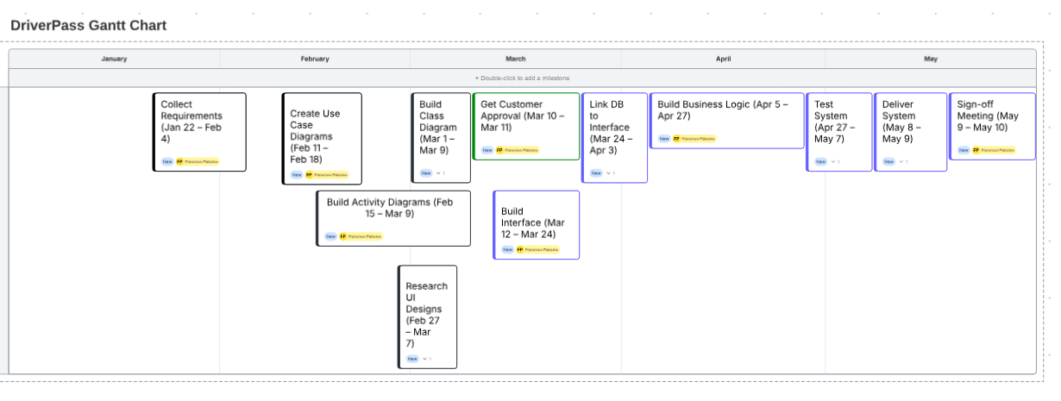
Black = Planning Phase, Green = Customer Approval, Blue = Development and Delivery

